Digital Signal Processing
Year : 2016-17 Div : B.E. A,B,C
Lecture – 08

- Write equation for circular convolution.
If x1[n] = [1, 2, 3, 4, 6] and x2[n] = [1, -1, 2, 0, 3, -2] then find circular convolution of x1 and x2.
- What is zero padding? Explain using an example.
- Find circular convolution of following signals:
  - x1[n] = [1, -2, 0, 4] and x2[n] = [1, -1, 1]
  - x1[n] = [1, -2, 0, 4] and x2[n] = [1, -1, 1]
  - x1[n] = [-1, 5.5, 0.2] and x2[n] = [1, 1, 1]
  - x1[n] = u[n]-u[n-5] and x2[n] = u[n]-u[n-2]

Q2.)ZERO PADDING
Zero padding consists of extending a signal (or spectrum) with zeros. It maps a length signal to a length signal, but need not divide .
Definition:
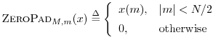 | (7.4)

where , with 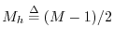 for odd, and for even. For example,
In this example, the first sample corresponds to time 0, and five zeros have been inserted between the samples corresponding to times and .
Figure 7.7 illustrates zero padding from length out to length . Note that and could be replaced by and in the figure caption.
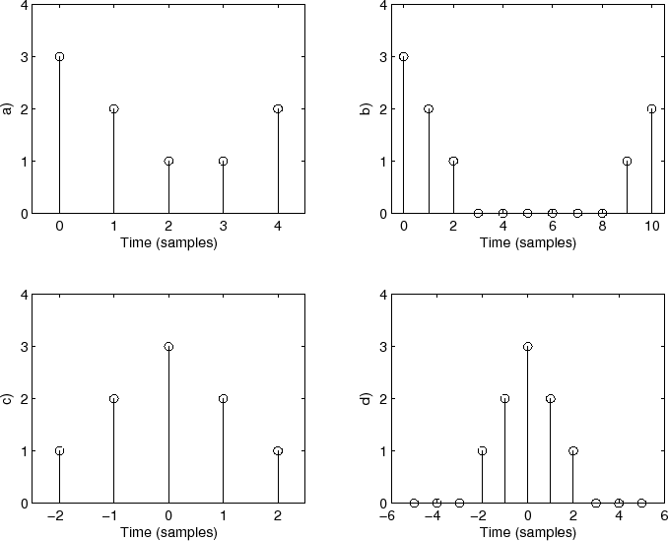
Figure 7.7: Illustration of zero padding: a) Original signal (or spectrum) plotted over the domain where (i.e., as the samples would normally be held in a computer array). b) . c) The same signal plotted over the domain which is more natural for interpreting negative times (frequencies). d) plotted over the zero-centered domain.
Note that we have unified the time-domain and frequency-domain definitions of zero-padding by interpreting the original time axis as indexing positive-time samples from 0 to (for even), and negative times in the interval.^{7.8} Furthermore, we require when is even, while odd requires no such restriction. In practice, we often prefer to interpret time-domain samples as extending from 0 to , i.e., with no negative-time samples. For this case, we define ``causal zero padding'' as described below.

